# ASSIGNMENT 3- A simple RESTFUL API using React.js, Database Creation, and Creating Index

**Name: INDLA LAKSHMI PRASANNA**

**Roll no:20NN1A1285**

# E-Mail:indlalakshmi1234@gmail.com

**College: Vignan’s Nirula Institute of Science and Technology for Women’s**

# Restful API code

**Rest Output on Thunder Client**

**This is the output when we create an API using REST.**

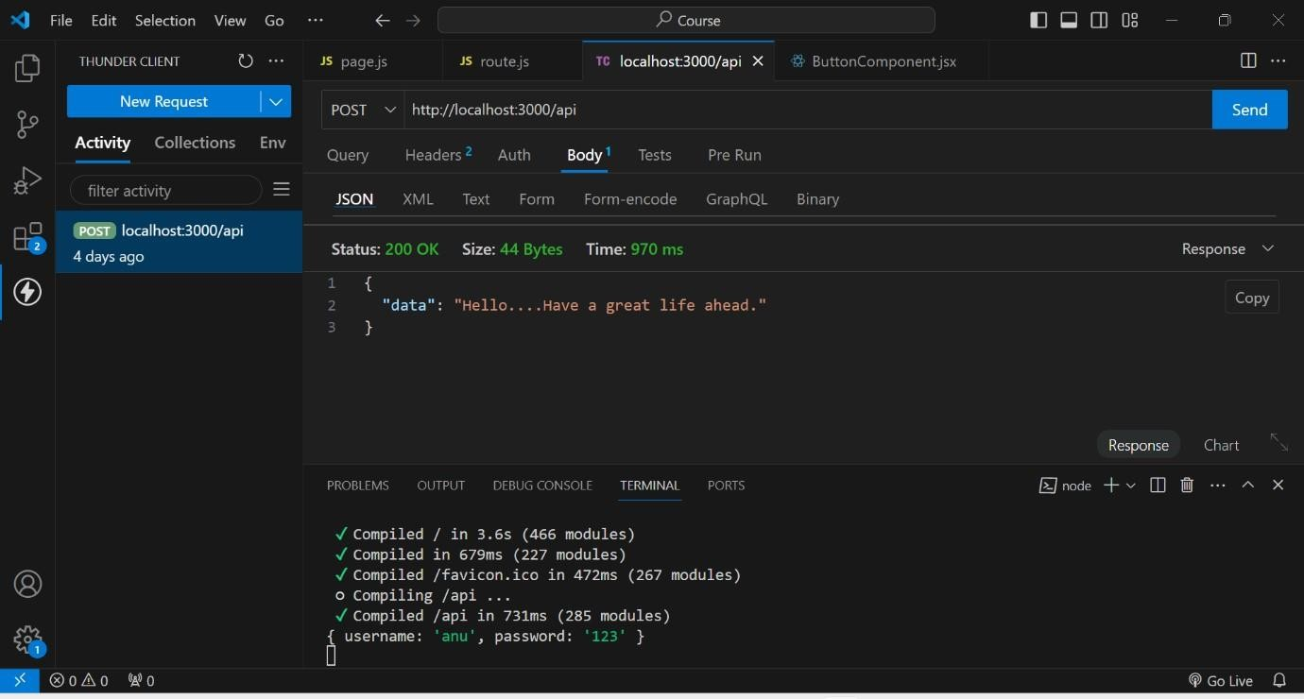

# DataBase Creation

1st we created a database named test

In that test we created a collection named Students

And finally by using ADD DATA , we added data of the students like rno, name, age.

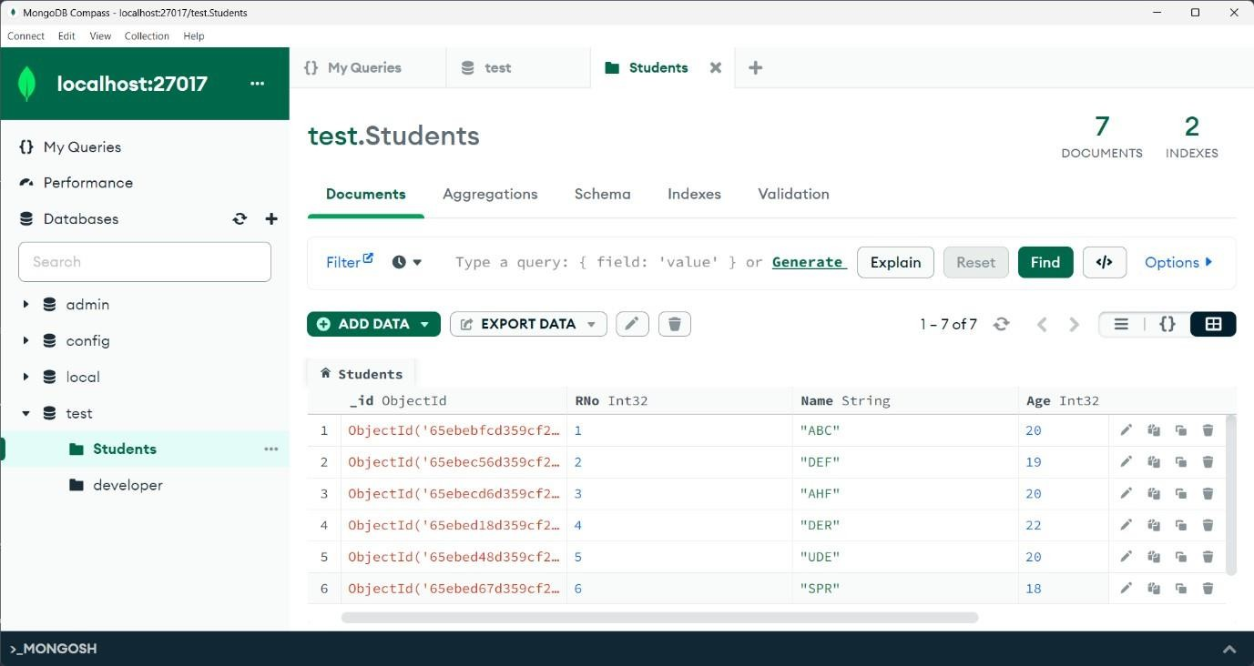

# Indexing Creation

As rno is the unique attribute through which we identify a student uniquely. So, here I created an index based on Rno. And assigned unique key to it.

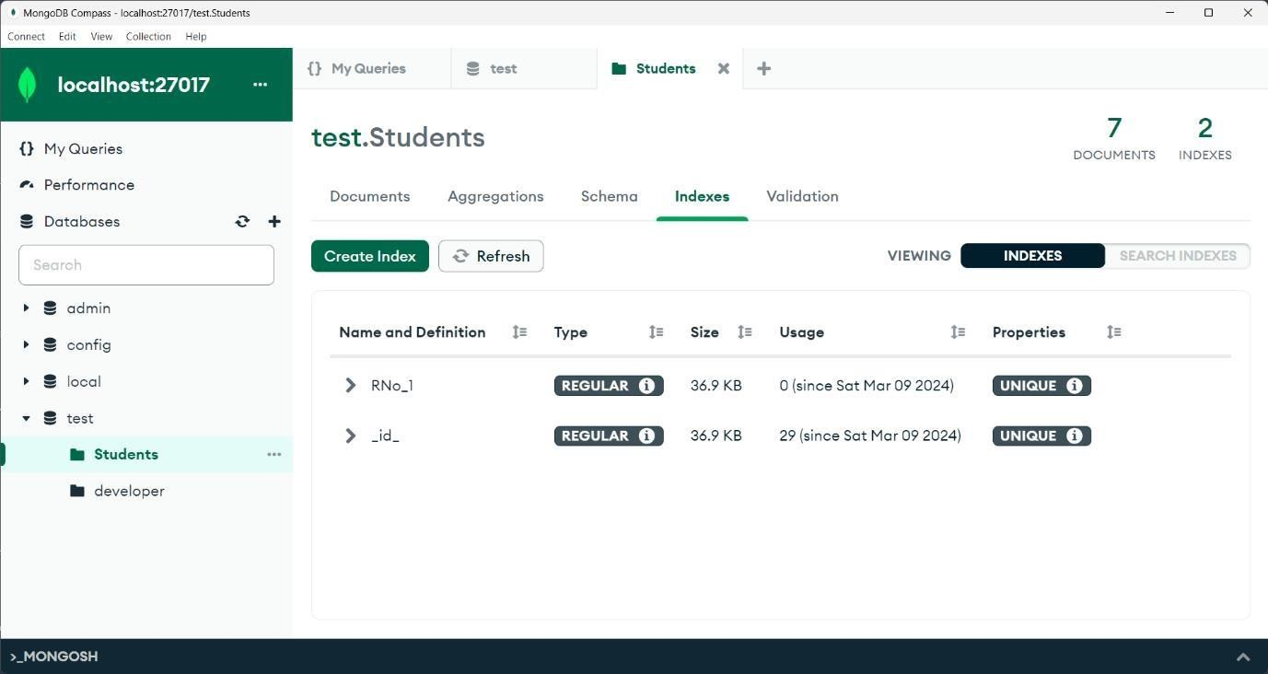

# Indexing usage

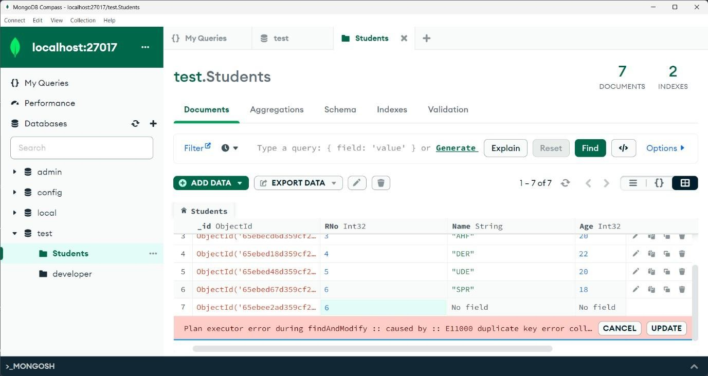As we gave Rno as unique, if we try to insert a duplicate document that is existed it shows an error like. Duplicate collection.